**Tutorial – Mobile GUI pack #2**

**1.FILE INCLUDE**

15 file psd (Named as function)

**2.USED FREE FONTS (** **included this pack ) ( Before using install fonts )**

- JuneBug

download - <http://www.ffonts.net/JuneBug.font>

- ace-gaffigan -

download - <http://www.ffonts.net/ace-gaffigan.font>

**3.HOW TO USE.**

**- Change color base windows:**

**- Change color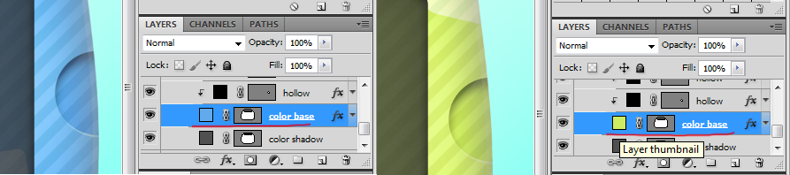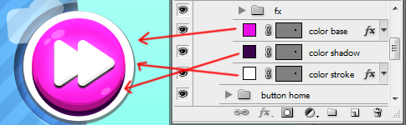 buttons:**

**Any questions please send mail to:**

**games.redgear@gmail.com**

**MORE GRAPHICS**

[**http://graphicriver.net/user/Redgear/portfolio**](http://graphicriver.net/user/Redgear/portfolio)

**Thanks for watching**